**HTML sup Tag**

Last Updated : 19 Jul, 2022

The <sup> tag in HTML describes the text as a superscript text. Here the text is above the baseline of the text and that text appears in a smaller font.

**Syntax:**

<sup> Content... </sup>

**Example 1:**

**html**

|  |
| --- |
| <!DOCTYPE html>  <html>    <head>      <title>HTML sup Tag</title>  </head>    <body style="text-align: center;">        <h1 style="color: green;">          GeeksforGeeks      </h1>        <h3>HTML &lt;sup&gt; Tag</h3>        <p>a<sup>2</sup></p>  </body>    </html> |

**Output:**

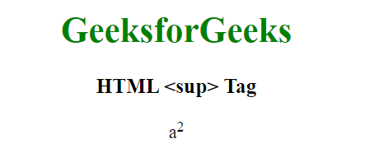

**Example 2:**

**html**

|  |
| --- |
| <!DOCTYPE html>  <html>    <head>      <title>          HTML sup Tag      </title>        <style>          sup {              vertical-align: super;              font-size: medium;          }      </style>  </head>    <body>      <p>          Examples to demonstrate          superscript text      </p>        <p>2 <sup>4</sup>=16</p>      <p>X <sup>4</sup>+ Y<sup>6</sup></p>      <p>9<sup>th</sup> of september</p>        <p>          Change the default CSS settings          to see the effect.      </p>  </body>    </html> |

**Output:**

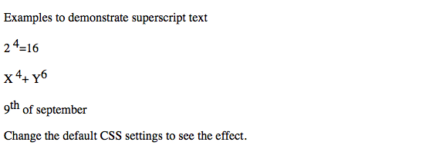

**Supported Browsers:**

* Google Chrome
* Edge 12 and above
* Internet Explorer
* Firefox 1 and above
* Apple Safari
* Opera